**Iron-sulfur and Iron-sulfur protein**

**Abstract : Iron -sulfur protein s are proteins characterized by the presence of iron-sulfur clusters containing sulfide-linked di-, tri-, and tetra iron centers in variable oxidation states.Iron-sulfur clusters play an important role in the oxidation-reduction reactions of mitochondrial electron transport. They have many other functions including catalysis as illustrated by aconitase The prevalence of these proteins on the metabolic pathways of most organisms leads some scientists to theorize that iron-sulfur compounds had a significant role in the origin of life in the iron-sulfur world theory.Recently,Dr. XieCan at School of Life Sciences, Peking University and his collaborators discovered a novel magnetoreceptor protein (named MagR)and suggested a biocompass model for animal magnetoreception and navigation.This article will give a brief introduction to the iron -sulfur protein’s structural motifs, biosynthesis and latest research of iron -sulfur protein in magnetic protein biocompass.**

**Key words : iron -sulfur protein; mitochondrial electron transport; iron-sulfur world theory ; magnetoreceptor protein ;structural motifs; biosynthesis; magnetic protein biocompass**

## **Structural motifs**

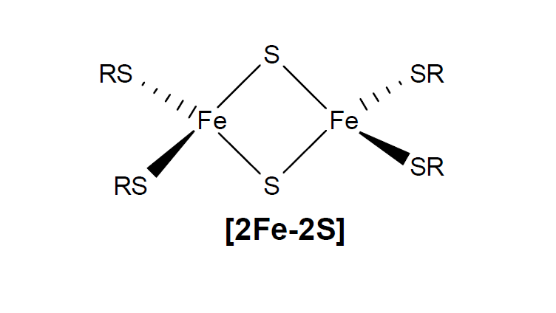There are many kinds of Fe-S proteins,but in almost all Fe-S proteins,the Fe centers are tetrahedral and the terminal ligands are thiolato sulfur centers from cysteinyl sesidues. The sulfide groups are either two- or three-coordinated. Three distinct kinds of Fe-S clusters with these features are most common---2Fe-2S clusters(Figure 1),4Fe-4S clusters(Figure 2),3Fe-4S(Figure 3) clusters.[1]

Figure 1|**2Fe-2S clusters[2]**

The simplest polymetallic system, the [Fe2S2] cluster, is constituted by two iron ions bridged by two sulfide ions and coordinated by four cysteinyl ligands (in Fe2S2 ferredoxins) or by two cysteines and two histidines (in Rieske proteins). The oxidized proteins contain two Fe3+ ions, whereas the reduced proteins contain one Fe3+ and one Fe2+ ion. These species exist in two oxidation states, (FeIII)2 and Fe(III)Fe(II).[1]

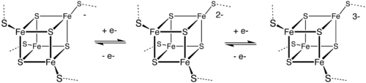

Figure 2| **4Fe-4S clusters[1]**

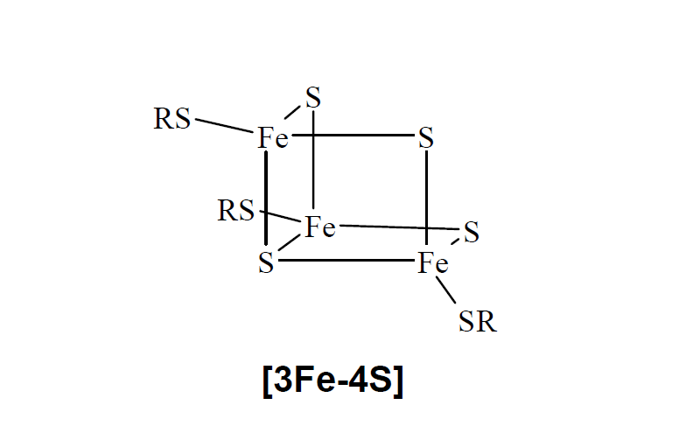A common motif features a four iron ions and four sulfide ions placed at the vertices of a cubane-type structure. The Fe centers are typically further coordinated by cysteinyl ligands[1]

Figure 3| **3Fe-4S clusters[2]**

Proteins are also known to contain [Fe3S4] centres, which feature one iron less than the more common [Fe4S4] cores. Three sulfide ions bridge two iron ions each, while the fourth sulfide bridges three iron ions. Their formal oxidation states may vary from [Fe3S4]+ (all-Fe3+ form) to [Fe3S4]2− (all-Fe2+ form).[1]

## **Biosynthesis**

The biosynthesis of the Fe-S clusters has been well studied.[6][7][8] The biogenesis of iron sulfur clusters has been studied most extensively in the bacteria E. coli and A. vinelandii and yeast S. cerevisiae. At least three different biosynthetic systems have been identified so far, namely nif, suf, and isc systems, which were first identified in bacteria. The nif system is responsible for the clusters in the enzyme nitrogenase. The suf and isc systems are more general. The yeast isc system is the best described. Several proteins constitute the biosynthetic machinery via the isc pathway. The process occurs in two major steps: (1) the Fe/S cluster is assembled on a scaffold protein followed by (2) transfer of the preformed cluster to the recipient proteins. The first step of this process occurs in the cytoplasm of prokaryotic organisms or in the mitochondria of eukaryotic organisms. In the higher organisms the clusters are therefore transported out of the mitochondrion to be incorporated into the extramitochondrial enzymes. These organisms also possess a set of proteins involved in the Fe/S clusters transport and incorporation processes that are not homologous to proteins found in prokaryotic systems..

Figure 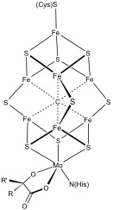4| Structure of the FeMoco cluster in nitrogenase. The cluster is linked to the protein by the amino acid residues cysteine and histidine.[1] ..

## **Magnetic protein biocompass**

Magnetic sensing is one of the most controversial animal senses , many species ,such as Monarch butterflies, bats,pigions, turtles, dolphins, the mole rat, and migratory birds, has the ability to detect the Earth's magnetic field (hereafter magnetoreception).A large amount of researches in animal behavior studies have been done during the past centuries. Yet the biological nature of such magnetosensing phenomenon remains unknown.

Recently, a research group in Peking University report a putative magnetic receptor(*Drosophila* CG8198, here named MagR) and a multimeric magnetosensing rod-like protein complex,The magnetosensing complex consists of the identified putative magnetoreceptor and known magnetoreception-related photoreceptor cryptochromes (Cry), has the attributes of both Cry- and iron-based systems, and exhibits spontaneous alignment in magnetic fields, including that of the Earth. Such a protein complex may form the basis of magnetoreception in animals, and may lead to applications across multiple fields. [3][4]

**About Dr Xie’s research**

There is a light-sensitive protein in the eye called cryptochrome (Cry),which has suggested previous research, that plays a key role in magnetic sensing abilities, but Dr Xie and colleagues reasoned it would need to team up with other proteins to actually form a compass. There are three main strongly magneticmaterials known in biological systems: ferrimagnetic minerals (including iron-nickel oxides), iron-binding proteins,and iron-sulphur(Fe-S) cluster proteins. Iron-sulphur cluster proteins play critical roles in numerous cellular functions, especially electron transportation (in which Cry may be involved), and can possess strong magnetic properties, which make them one of the most likely candidates for MagR.thus they predict the existence of a protein which forms a magnetic entity (designated MagR) that interacts with Cry and functions as the actual magnetoreceptor (Fig. 1a,b)[3]. To make further research,they screened the genome of fruit flies and discovered an iron-containing protein they dubbed MagR (for magneto-receptor), which can have features of a magnet when polymerised.According to Dr. Xie, the protein complex spontaneously aligns in the direction of external magnetic fields,and they also showed through immunohistochemical studies biochemical and biophysical methods that the MagR/Cry complex is stable in the retina of pigeons. Biochemical and biophysical methods indicated this complex can also forms in butterfly, rat, whale and human cells. [5]

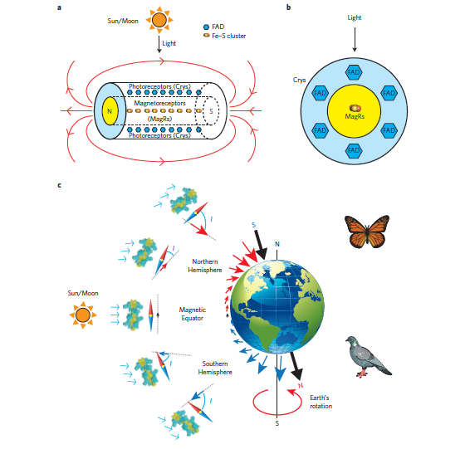

Figure modified from Qin et al. Nature Materials, advance online publication, 16 November 2015 (DOI 10.1038/nature4484).

Figure | The biocompass model of animal magnetoreception and navigation. a, A nanoscale Cry/MagR magnetosensor complex with intrinsic magnetic polarity acts as a light-dependent biocompass. Linear polymerization of Fe–S cluster-containing magnetoreceptors (MagR) leads to the formation of a rod-like biocompass at the centre (core, yellow), surrounded by photoreceptive cryptochromes (Cry; outer layer, cyan). b, Cross-section of a, indicating that electron transportation from the FAD group in Cry to the Fe–S cluster in MagR upon light stimulation may be possible. c, The biocompass model of magnetoreception. In animal navigation systems, the Cry/MagR magnetosensor complex may act as a biological compass that perceives information from the Earth’s geomagnetic field, such as polarity (as with a conventional compass), intensity and inclination. Earth’s magnetic poles (black arrows) are offset from the axis of rotation (black line). The inclination angle (labelled as ‘I’) and intensity of the field are indicated by the direction and length of the arrows (red in the Northern Hemisphere and blue in the Southern Hemisphere). MagR and Cry/MagR magnetosensors from two species, monarch butterfly (Danaus plexippus, upper right) and pigeon (Columba livia, lower right), were tested in this study, highlighting the evolutionarily conserved biocompass model.[3]

**Sceptical voices**

Some scientists are not convinced that the biological needles function like compasses in living organisms. Xie’s team has shown that MagR and Cry are produced in the same cells in pigeon retinas — the birds’ proposed magnetoreception center —but MagR and Cry are found in many cells. In the meantime, some believes that the lack of an exact mechanism for how the protein complex senses magnetism, or how any signal it sends might be processed by the brain, gives some researchers pause. MagR’s biocompass activity might simply be the result of experimental contamination.[6]In conclusion, this research still need an amount of evidences to prove their hypothetics.

**Outlook**

The biocompass model may serve as a step towards fully uncovering the molecular mechanism of animal navigation and magnetoreception.It might also become an invaluable tool for using magnetic fields to control cells，,And, with the development of biocompass’ research, it will be a good news on developing our sense of directions by taking some medicines base on it,and some disease, such as Alzheimer disease, might be cured by this research. What’s more, it can even be a preparation for the outer space migration.

**Reference**

[1] Iron-sulfur protein,Wikipedia.

[2]CHEMISTRY􀂀THE CHINESE CHEM. SOC., TAIPEI􀂁March. 2005 Vol. 63, No.1, pp.141~148

[3]Siying Qin, et al. A magnetic proteinbiocompass. Nature Materials (2015) doi:10.1038/nmat4484

[4]An animal magnetic protein compass discovered by Xie Can's team of PKU NOV . 17 2015

[5]Protein compass' may explain how pigeons find their way home .ABC science .17 Nov 2015

[6] ‘Discovery of long-sought biological compass claimed.’Nature. 19 November 2015